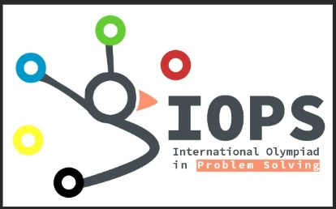

**International Olympiad in Problem Solving (IOPS)**

<https://www.facebook.com/IOPSnews>

The main idea behind the creation of the « International Olympiads in Problem Solving (IOPS) » is to propose a common contest for both school students and university students. The aim of the Olympiads is to showcase the skills in problem solving and competitive programming in the computing sciences and engineering among the participating countries. Thus, the participating contestants can share their proficiencies in information and communication technologies.

The « International Olympiads in Problem Solving (IOPS) » is to be organized yearly by one of the participating countries. For each participating country, a national steering committee is appointed to make intense training and fair selection of the national delegation. The national steering committee is free to choose the adequate procedures for training and conducting local and national contests. The national delegation is composed of 4 to 12 contestants and two representatives of the national steering committee.  Students compete individually and try to solve the maximum problems by finding the most efficient solutions. Any school student or university student aged no more than 25 years is eligible to compete in the Olympiad.

The international steering committee is responsible for the conduction of the Olympiad's Final. The number of contestants per national delegation (4 to 12) is fixed annually based on the number of participating countries, the format of the Olympiads Finals (Multi-Sites or Single-Site) and the capacity(ies) of the site(s). The international steering committee organizes yearly an award ceremony in one of the participating countries. The top three contestants and one of the representatives of their delegations are invited to the award ceremony.

Prof. Adel Bouhoula, the founder and former chair of the Tunisian Collegiate Programming Contest for five years, is proud to have launched this exciting initiative on April 28, 2017, where excellent contestants from different countries as well as fresh insights from new partners will make of IOPS a worldwide appealing event.

Egor Suvorov, ACM ICPC WF 2014 Champion and IOI 2012 gold medalist, welcomed to be the Honorary Chair of this new Olympiad.

For the moment many countries including China and Japan were delighted to be founding members of this international Olympiad.

Three International committees are under construction:

* The International Steering Committee
* The International Scientific Committee
* The International Executive Committee

Email contact: [iops.contact@gmail.com](mailto:iops.contact@gmail.com)

